|  |
| --- |
| **مدر الضاد** |
| **المؤتمر الدولي 2024** |
| **رابطة أقسام تعليم اللغة العربية بإندونيسيا** |



Title should be clear, brief and informative. No more than 16 Words. Book Antiqua 16pt (Eng), Sakkal Majalla 20pt (Ar)

**First Author*, Second Author, Third Author (11pt)**

*First Affiliation, Country (10pt)*

*Second Affiliation, Country (10pt*

*Third Affiliation, Country (10 pt)*

*\*Corresponding E-mail:* [*author@institute.xxx*](mailto:author@institute.xxx) *(10pt)*

|  |
| --- |
| *Abstract (10pt)*  *Abstract is written in English (Book Antiqua size 10pt) and Arabic (Sakkal Majalla 13pt) using with one space. It is a concise and comprehensive summary of the contents of an article, allowing readers to understand the contents of the article quickly and easily, as well as allowing people who are interested in the document to retrieve it from the abstracting and indexing database. And it contains the main problem and/or research objectives, and showing the approach or method used to solve it, and presenting important findings, conclusions, and implications of research results. The abstract summarizes the reasons for the research being undertaken, the approach or method chosen, the key results, and the key conclusions. Abstracts are presented in a paragraph containing 150-250 words followed by 3-4 keywords. There should be no spelling, grammar, and expression errors in the language used.*  ***Keywords:.....,.....,.....***  مستخلص البحث  مستخلص البحث مكتوب باللغة الإنجليزية (*Book Antiqua* مقاس 10 نقاط)، وباللغة العربية ( *Sakkal Majalla*13 نقطة) بمسافة واحدة. هو ملخص موجز وشامل لمحتويات المقالة، مما يسمح للقراء بفهم محتويات المقالة بسرعة وسهولة، كما يسمح للأشخاص المهتمين بالمستند باسترجاعها من قاعدة بيانات الملخص والفهرسة. وأنه يحتوي على أهم مشكلة و / أو أهداف بحثية، ويوضح النهج أو الطريقة المستخدمة لحلها، ويقدم نتائج واستنتاجات ونتائج مهمة من النتائج. يلخص الملخص أسباب البحث الجاري ومنهجية البحث أو الطريقة المختارة والنتائج الرئيسية والاستنتاجات الرئيسية. يتم تقديم مستخلص البحث في فقرة تحتوي على ١50-25٠ كلمة تليها 3-4كلمات مفتاحية. يجب ألا يكون هناك أخطاء إملائية وقواعد وتعبيرات في اللغة المستخدمة.  **الكلمات المفتاحية:...،...،...** |

# Introduction/ المقدمة

The purpose of an introduction is to justify the reasons for writing about your topic. Your goal in this section is to introduce the topic to the reader, provide an overview of previous research on the topic, and identify your own hypothesis, research, or study. If you introduce and define key words in your abstract, you need to introduce and define them in this section. Font Size 12, Book Antiqua, 1, 5 spaced (Eng) and Font Size 18, Sakkal Majalla, 1 spaced (Ar). All the subheadings in this section should be in Font Size 12, Book Antiqua, 1, 5 spaced (Eng) and Font Size 18, Sakkal Majalla, 1 spaced (Ar). The first letter of each word in subheading should be capital. Introduction consists of *Background of the Study, Problems/Aims and Review of Literature* or *Previous Research*.

# Methods/ منهجية البحث

This section explains the rationale for the application of specific procedures or techniques used to identify, select, and analyze information applied to understanding the research problem/project, thereby, allowing the readers to critically evaluate your project’s/study's overall validity and reliability. Font Size 12, Book Antiqua, 1, 5 spaced (Eng) and Font Size 18, Sakkal Majalla, 1 spaced (Ar). All the subheadings in this section should be in Font Size 12, Book Antiqua, 1, 5 spaced (Eng) and Font Size 18, Sakkal Majalla, 1 spaced (Ar). The first letter of each word in subheading should be capital. There is no methodology for non research paper.

**Result and Discussion/ النتيجة والمناقشة**

The discussion is written to interpret and describe the significance of your findings in light of what was already known about the issues being investigated, and to explain any new understanding or insights about the problem after you have taken the findings into consideration. It should connect to the introduction by way of the research questions or hypotheses you posed and the literature you reviewed, but it does not simply repeat or rearrange the introduction; this section should always explain how your study has moved the reader's understanding of the research problem forward from where you left them at the end of the introduction. Font Size 12, Book Antiqua, 1, 5 spaced (Eng) and Font Size 18, Sakkal Majalla, 1 spaced (Ar).

The research findings in the form of research data are further discussed or critically interpreted with particular relevant theoretical approach. Data can also be supported with the presentation of tables, images, etc. Captions for table is written above it with sequenced numbering so that it can be easily referred to, though not put under the pointing sentence/ paragraph. Captions for images are placed below the picture, also with providing sequenced numbering. One page only accommodates a table or an image with a maximum of two-thirds the size of the page, and size adjusted as efficiently as possible. Example:

**Table 1. Table Title**

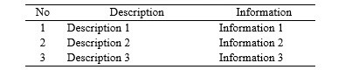

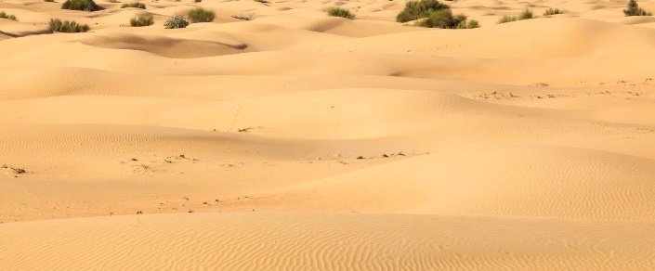

**Image 1. Image Title**

# Conclusion/ الخلاصة

The conclusion is intended to help the readers understand why your research should matter to them after they have finished reading the paper. It is not just a summary of the main topics covered or a re-statement of your research problem, but a synthesis of key points and, if applicable, where you recommend new areas for future research. Font Size 12, Book Antiqua, 1,5 spaced (Eng) and Font Size 18, Sakkal Majalla, 1 spaced (Ar). All the subheadings in this section should be in Font Size 12, Book Antiqua, 1,5 spaced (Eng) and Font Size 18, Sakkal Majalla, 1 spaced (Ar). The first letter of each word in subheading should be capital.

# Acknowledgement/ الشكر والتقدير ****(Optional)****

This section allows you to thank all the people who helped you with the project. Write a thank you to the sponsor for research. Also write a thank you to the person who helped intensely in the research and writing of the article. Font Size 12, Book Antiqua, 1, 5 spaced (Eng) and Font Size 18, Sakkal Majalla, 1 spaced (Ar).

**References (**المراجع**) (***should use APA 6th referencing style.)*

80% primary references (journals, proceedings, research reports, patents, standards, historical documents, research books, etc., published no more than 5 years. 25% secondary literature (internet, books: published no more than 10 years). References should be typed in Alphabetical Order, Book Antiqua Font size of heading 12, 1 spaced and the minimum requirement is 25 references and it is suggested to use reference software like Mendeley or Zotero.